**Weekly Blog 9**

This week, I read a research paper by the name “COVID-19 Contact Tracing and Data Protection Can Go Together”

<https://mhealth.jmir.org/2020/4/e19359/pdf>

This is the wiki of the research paper-

<https://github.cs.adelaide.edu.au/2020-Mobile-and-Wireless-Systems/CovidGuard-F/wiki/Lokesh-Pathak--COVID-19-Contact-Tracing-and-Data-Protection-Can-Go-Together>

**Implementation –**

**My commit-** <https://github.cs.adelaide.edu.au/2020-Mobile-and-Wireless-Systems/CovidGuard-F/commit/660a5122e8b272d1607a6dfdb3b48b9f57b1bb05>

My part of implementation was focussed on the user-interface of the application. Previously, all the screens and activities were coded in a single file, which resulted in incorrect navigation of the application. The back buttons did not work and when they were clicked, the application exited and the home screen of mobile phone was visible.

Therefore, I worked for writing separate files for all the 3 android activities.

I made three files which are as follows,

1) SplashActivity.java

2) DiagnoseActivity.java

3) MetricsActivity.java

**Before on pressing back button –**

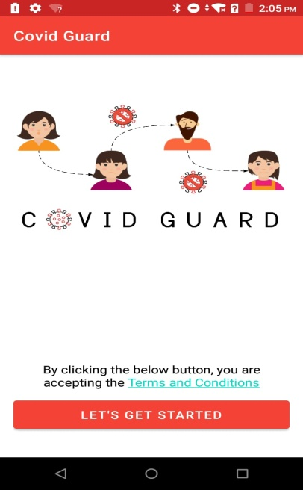 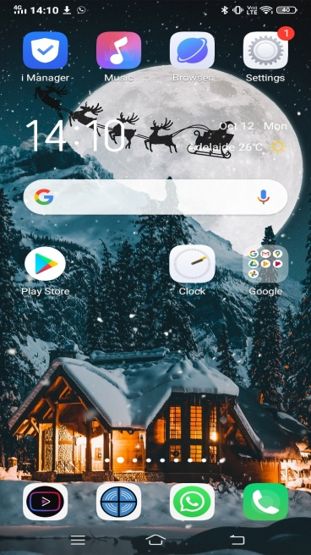

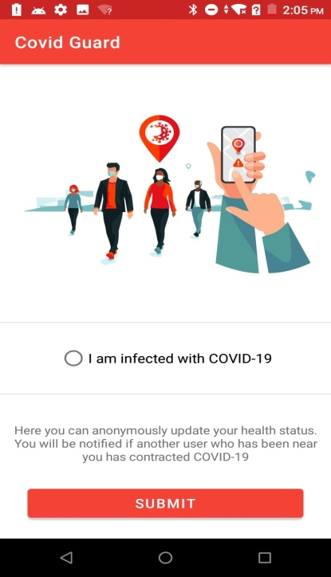 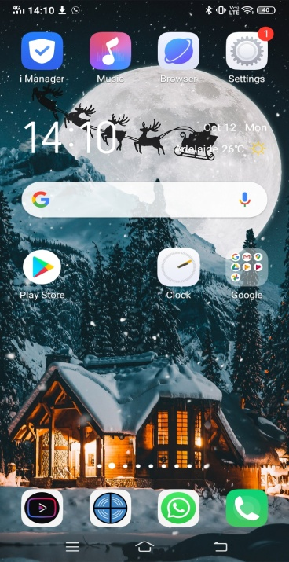

**After-**

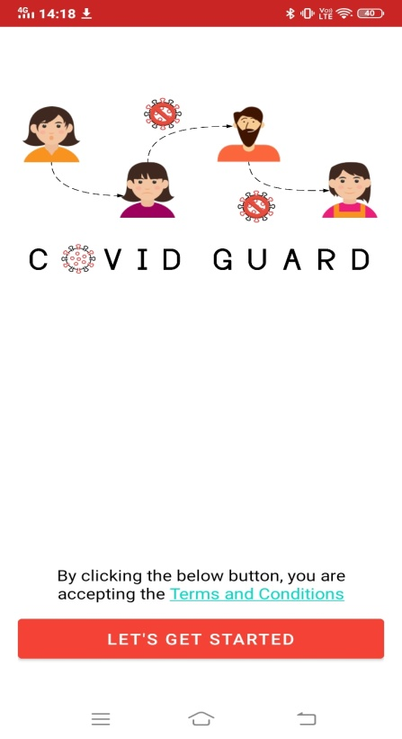 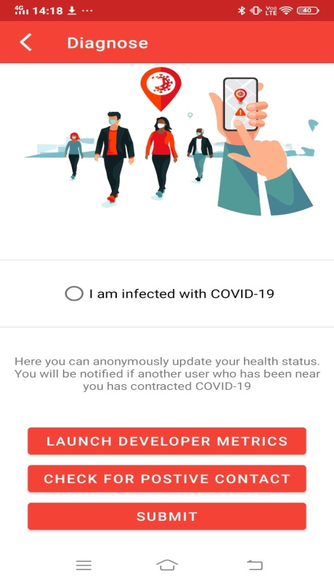 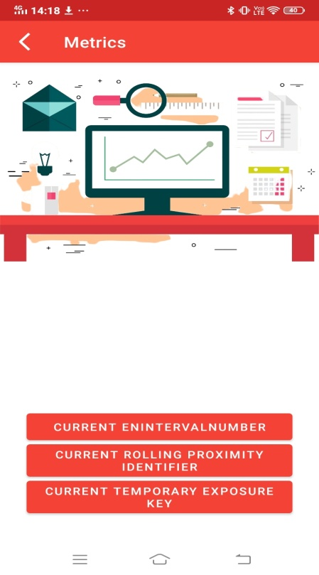

Now all the activities are separated, so this will be helpful for future development , as new activities can be added without interfering with the other.

**Work for next week- 1)** Work with Sreeram on user consent flow

2) Self-assessment test